**Abstract**

This guide walks the user through KAZAM SQUIX Label Printer driver

**Author**

Austin Hong

**Version**

1.0



**AME Design for Manufacture and Test**

**SQUIX Label Printer**

**Lab126 and Amazon.com all rights reserved.**

*This document contains confidential information. No part of this document may be reproduced in any form without the written consent of Lab126.*

**Table of Contents**

1. Hardware installation 4

2. Connecting Label Printer to Computer 4

3. Printing through FTP 4

3.1 Simple Test – using FTP client tool 4

3.2 Simple Test – using Standalone VI 4

4. Running from Kazam 5

4.1 Hardware config 5

4.2 Demo test sequence 5

5. Scripts 7

**Revision History**

|  |  |  |  |
| --- | --- | --- | --- |
| **Version** | **Date** | **Author** | **Description** |
| 1.0 | May 2020 | Austin Hong |  |
|  |  |  |  |
|  |  |  |  |
|  |  |  |  |
|  |  |  |  |
|  |  |  |  |

# Hardware installation

Refer SQUIX Operator's Manual: <https://www.cab.de/media/pushfile.cfm?file=2771>

** Allen Key (HW tool) is inside the printer, please refer page 7.

# Connecting Label Printer to Computer

Refer SQUIX Configuration Manual: <https://www.cab.de/media/pushfile.cfm?file=2772>

** Connecting via Ethernet Interface is more stable than Wi-Fi

# Printing through FTP

Refer SQUIX Configuration Manual, page 56 - 13.2 FTP Printing.

## Simple Test – using FTP client tool

1. Open FTP Client application (ex, FileZilla, WinSCP..)
2. Fill **hostname** with SQUIX IP address, **username**: ftpprint, **password**: print

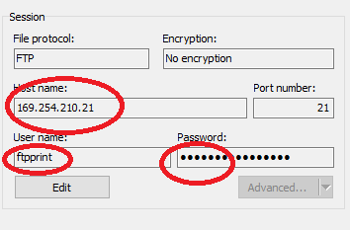

1. Upload one script file (**KAZAM**\trunk\Project\Library\SQUIX\scripts\scriptQR.txt) to printer through FTP – **make sure the transfer type is binary**
2. Confirm you get the QR code printed out.

## Simple Test – using Standalone VI

1. Open KAZAM\trunk\Project\Library\SQUIX\SQUIX Generate Code Label.vi
2. Fill **host** with SQUIX IP address, enable **using custom script**, put scriptQR.txt in **ScriptName**
3. Run the VI and confirm QR code printed out.

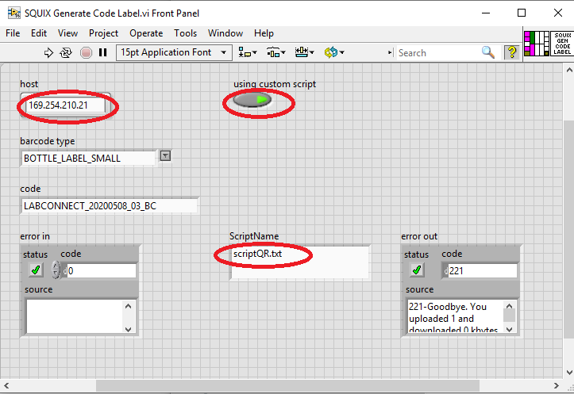

# Running from Kazam

## Hardware config

Refer "KAZM\trunk\Project\Demo\Prj_CFG\HardwareCFG.csv" line 56

|  |  |
| --- | --- |
| LABEL_PRT_CTL | SQUIX@169.254.210.21 |

SQUIX is a printer model name and 169.254.210.21 is an IP address of the printer, so add the line to your HardwareCFG.

## Demo test sequence

"C:\git\kazam\Lab126-ame-kazam\trunk\Project\Demo\Prj_CFG\Demo_Label_Printer.csv"

Input parameters: Function, Template, Data, UseScript, ScriptName

1. If UseScript=TRUE
   1. The script file which is specified in **ScriptName** parameter will be used as a template. – the script file must be located in “KAZAM\trunk\Project\Library\SQUIX\scripts” folder.
   2. The barcode will be replaced with the value in **Data** parameter.

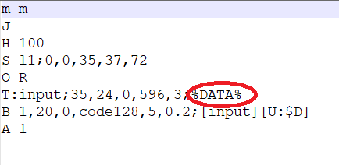

1. If UseScript=FALSE
   1. Hardcoded templates will be selected by **Template** parameter.

Input Parameter Examples)

1. Function=PRINT|Template=BOTTLE_LABEL_SMALL|Data=20200511BQ5|UseScript=FALSE
   1. As UseScript=FALSE, hardcoded template BOTTLE_LABEL_SMALL will be used

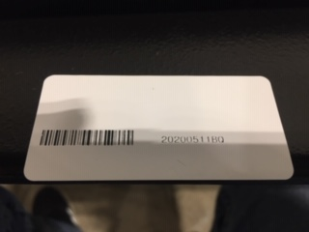

1. Function=PRINT|Template=BOTTLE_LABEL_QR|Data=20200511BQ5|UseScript=FALSE
   1. As UseScript=FALSE, hardcoded template BOTTLE_LABEL_SMALL will be used

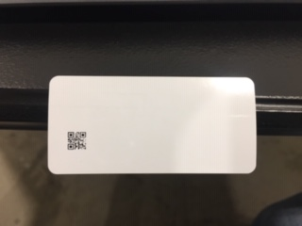

1. Function=PRINT|Template=BOTTLE_LABEL_TEST|Data=2020051155555|ScriptName=scriptCustomStringsData.txt|UseScript=TRUE
   1. As UseScript=TRUE, scriptCustomStringsData.txt will be a template,

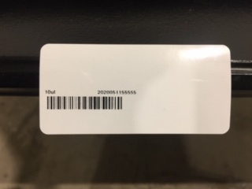

# Scripts

Refer the programming manual: <https://www.cab.de/media/pushfile.cfm?file=3047>

Script example: scriptCodeAsideData.txt

m m Set measurement to millimeters

J Jobstart

H 100 Heat (Speed) setting (100mm/sec)

S l1;0,0,35,37,72 Size of the Label (35 x 72mm, gap 2mm)

O R Orientation Rotated by 180deg

T:input;35,24,0,596,3;%DATA% Text line to print barcode characters

B 1,20,0,code128,5,0.2;[input][U:$D] Barcode CODE128

A 1 Amount of labels (in this sample 1)

More details of commands:

B x, y, r, type,size,text //refer page 110 in programming manual

T x,y,r, font,size . . ;data //refer page 365 in programming manual

